**Reference point formation by market investors**

*By Doron Kliger, Andrey Kudryavtsev, Journal of Banking & Finance 32 (2008)*

* **ABSTRACT**

Disposition effect relies on the notion of a reference point distinguishing between losses and gains.

We hypothesize that salient events taking place during a stock’s holding period influence investors’ perceptions and make them update the stock’s reference point.

We discover that the earnings announcements played a role in reference point formation when they were not anticipated, when :

* analysts’ earnings forecasts failed to provide accurate predictions,
* earnings announcements were followed by market price reactions.

In the present work, we argue that investors may modify their view on a financial asset upon the arrival of new information, such as firms’ earnings announcements.

2 testable hypotheses :

* unexpected earnings announcements should be followed by investors updating the reference points of their investments,
* such reference point updates should not be detected when the announced earning figures were expected by the investors.
* **OBJECTIVES**

The goal of the study is to empirically test whether firm-specific salient events drive investors to update the reference levels they attribute to the prices of the firms’ stocks.

Our hypothesis that salient firm-specific events (ex : firms’ earnings announcements) may influence investors’ attitudes and modify the reference points may be used to sharpen the reference points’ identification.

For a large sample of stocks, we use market prices and trading volumes to check if the disposition effect is exhibited with respect to the stocks’ prices at the firms’ earnings announcements.

* **DATA USED**

The main data source for our work is the dataset of quarterly earnings announcements of companies listed on NYSE, NASDAQ, and AMEX, as provided by Thomson First Call for the first 6 months of the year 2007.

This dataset defines a firm’s earnings surprise as the difference between its actual quarterly EPS and consensus EPS (an average of the estimates by all analysts following the company).

The earnings surprises in the dataset are updated following firms’ earnings publications and are classified into 3 categories:

* upside surprises (US; actual EPS > consensus EPS),
* met expectations (ME; actual EPS = consensus EPS),
* downside surprises (DS; actual EPS < consensus EPS).

The basic idea of the proposed tests is to compare the trading volumes at upward and downward crossings of the hypothesized reference level, measured by the closing stock price on the day following the announcement.

We record the trading volumes at the above defined price crossings for each event in our sample, provided that they took place :

* before the firm’s subsequent quarterly earnings announcement
* within 70 days from the firm’s earnings announcement day. One upward and one downward crossing are recorded for each stock.

We exclude :

* Stocks without such data over the specified time period
* Stocks with less than one year of trading data available prior to the earnings announcement and stocks without information on the value of the respective firm’s market capitalization

We obtain our working sample of 4517 earnings surprises for 3126 distinct firms.

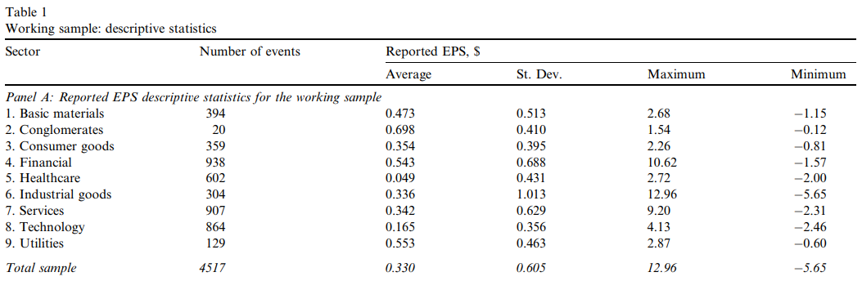

* **METHODS**

For assessing the news content in the earnings announcements, we divide the sample according to 2 ‘‘news” proxies :

* earnings surprise: the surprise relatively to the analysts’ opinion (US, ME and DS),
* market reaction: the market-model adjusted (MMA) stock price reaction to the earning announcement.

Events are classified into 3 roughly equally sized categories:

* **positive return (PR)** : MMA abnormal stock return around the event > 1.36%.
* **intermediate return (IR)** : 1.36% < MMA abnormal return is between 2.09%.
* **negative return (NR) :** MMA abnormal return < 2.09%.

To estimated return-related volume pattern, we use price and trading volume data for the 251 trading days preceding each earnings announcement.

*ln(Vit) = natural logarithm of the stock’s trading volume on day t for firm-specific (earnings-announcement) event i.*

*dir_dummyit = dummy variable taking the value 1 if the day-t return on the stock for which event i took place was positive, and 0 otherwise.*

$γi$*coefficients provide estimates for the (natural log) volume differences between days with positive and negative stock returns.*

The regressions yield positive $γi$ estimates for the majority of the events 🡪 suggest that the trading volume at positive return days is generally > at negative return days.

To control for the influence of this returnrelated volume pattern, we compute adjusted volumes at upward crossings :

*V(Ui) = event i’s trading volume at the upward price crossing.*

*V(Di) = event i’s trading volume at the downward price crossing.*

If investors update the reference point on the event day, then the tendency of selling winners should drive the trading volume at upward crossings to be abnormally high, that is :

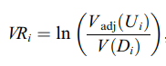We test it using the parametric and non-parametric tests :

* volume ratio test statistic *(for the parametric analysis)* :

According to our hypothesis, we expect $μ$ (VRi) to be significantly > 0 within the US and DS earnings surprise categories, as well as within the PR and NR categories.



* volume indicator statistic *(for the non-parametric analysis)* :

We conjecture that the proportion of VIi equaling 1 would be > half of the volume indicator within the US and DS categories, as well as within the PR and NR, but not within the ME and IR categories.

Hypothesis : surprising events drive the investors to update the reference levels.

* we expect to find significant evidence for the disposition effect when :
* EPS values are in discrepancy with analysts’ forecasts (within US and DS categories of the earnings surprise news proxy, but not within the ME category).
* the market reacted to the earnings announcements (within the PR and NR categories of the market reaction news proxy, but not within the IR category).
* **RESULTS**
* Tests based on the surprise relatively to analysts’ opinion :

The results of parametric and non-parametric tests are consistent with our hypotheses.

* Parametric test provides significantly $μ$ (VRi) $≠0$ within the US and DS categories.
* Non- parametric test yields significantly more than half VIi values equaling unity within the US and DS categories.

The evidence for the disposition effect tested over the whole sample is strongly significant by both tests.

The proportion of the events for which holds is significantly > 0,5.

* Tests based on stock price reactions :

As analysts’ opinion might not reflect correctly the market expectations, we analyze the market proxy measured by initial abnormal stock returns.

Hypothesis : only the events that caused a relatively strong market reaction drive investors to update their reference levels.

* we expect to find significant evidence for the disposition effect within PR and NR categories, but not within the IR category.

Both tests significantly corroborate the disposition effect : results based on the market reaction are consistent with the intuition that only salient ‘‘surprising events” drive the investors to update their perceptions.

* **CONCLUSION**

The main goal of our research is to test the hypothesis that company-specific events (ex : earnings announcements) drive investors to update their reference level, consequently influencing their behavior.

We take the stock price fixed at the day following the ‘‘event day” as a benchmark, that is, a potential reference point.

Our major finding is that investors update the reference level assigned to stocks subsequently to news regarding their values.

We are able to show that our findings are robust to the specification of the expectations proxy: both the ‘‘analysts’ proxy” and the ‘‘market proxy” provide.